LAB Instruction

What You Will Learn
- How to create form in HTML
- Demonstrate the results of GET and POST methods used on the form

Forms in HTML
PJ Perri, 2023

In this lab activity, you are required to design two HTML forms both of which look similar to the following image. Each form will have a different method.
You will also need to write answers to four questions on a docx file.
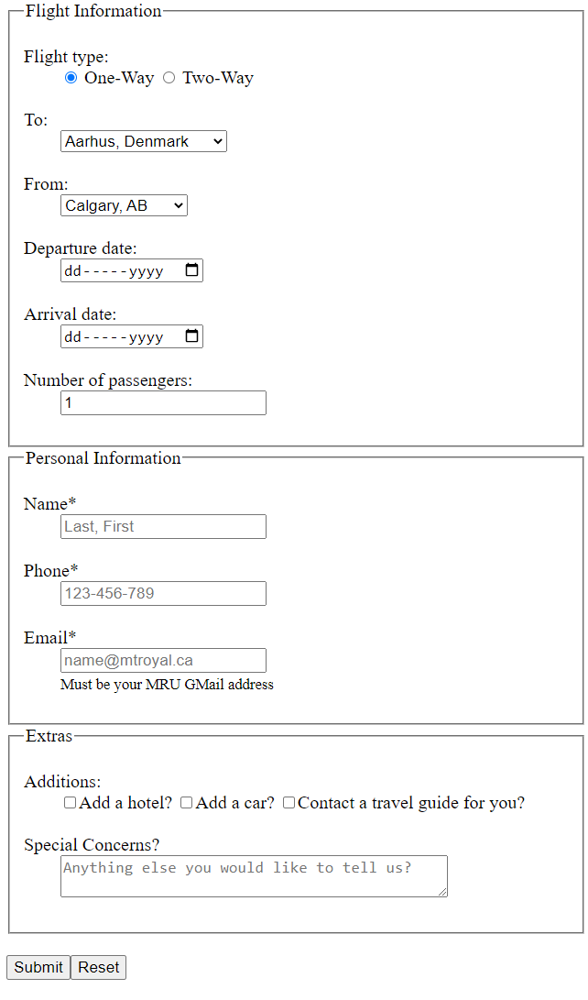
Figure 1: Prototype flight booking form created in HTML
General form specifications.

Your form must include:

- The three fieldsets and legends
- Use of a description list <dl></dl> and breaklines <br /> to layout form elements
  - Label are the description terms <dt></dt> and the form element(s) are enclosed by the description tag <dd></dd>
- Flight type labels must be clickable as well as their associated radio button.
  - Set an id=" " to the input element and ensure the label uses for=" "
  - Only one of the two buttons must be clickable at one time. Do this by ensuring both radio buttons have the same name value.
- From and To options can be any three international airports in the world. Their values must be the airport’s call letters.
  - Cite this website in your html comments
Bonus: Can you make one of the choices preferentially selected?
- Number of passengers must be at least 1
- All three personal information items are required and validated
  - Ensure those elements have the attribute that makes this so
  - ONLY USE HTML validation.
Check out the following resource and Google your others to find out how to make this happen:
    - https://www.abstractapi.com/guides/html-email-validation
  - Use <small> </small> element for the extra instruction associated with the email.
- The Extra Additions checkboxes should have clickable labels
- Special Concerns textarea is cols="40" wide.

Further general instructions:

- Make sure to all the code in a proper HTML format. For example, include a proper head, body, meta tags, semantic tags, and use indentation to make your code clear to read.
- Do not forget to validate your code before submitting it.

Form Methods and Actions

Create two versions (two webpages) of this form.

- The first version will use the GET method and its action will link to the provided webpage.
<form id="formOne" method="get" action="getResponder.html" >
  - Fill in and submit the form.
  - Examine both that with the getResponder.html page displays AND its URL. Be sure you can ‘read’ the query string in the URL.

- In your own words, describe how the query string in the URL is structured - explaining how the name attribute and other symbols are used to organize the URL to make the various data identifiable.

- As you have taken a programming course, right-click on the getResponder.html page and view the page source. The code you see there is JavaScript.
Identify and explain any ONE of the programming steps you see there and compare it to how one might code the same thing in Python.

- The second version will POST to your email account when you press Submit.
<form id="formOne" method="post" action="mailto: @mtroyal.ca" >
If you can figure out how to change the settings on your browser and your email account, you should be able to see the sent data. If not find that data by following this process:
  - Right click on your web page> Inspect
  - Fill in the form and press the Submit button on the web page
  - Open the Network tab
  - Click on the Name
  - Open the Payload tab – and look at the Query String Parameters
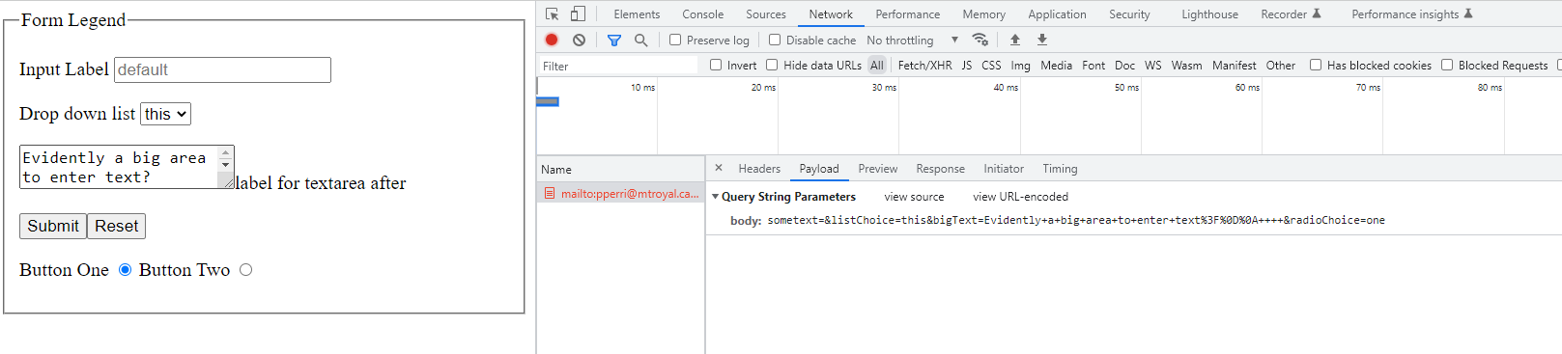
Figure 2: Examining a form's query string.
b
c
d
e

- When does the default form validation happen - when user enters data or when the form submit is called?

- Confirm you understand the differences between the GET and POST methods in an HTML form. List their differences.

